Considering the negative values are billing errors ,changed the minus values from Monthly _Charge column to 0
Query : UPDATE telecom_customer_churn
SET Monthly_Charge = 0
WHERE Monthly_Charge < 0;
KPIs
1. Total Revenue
Query : SELECT ROUND(SUM(Total_Revenue),2) AS total_revenue
FROM telecom_customer_churn;
Result :
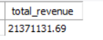
2. Total Customer
Query :SELECT COUNT(*) as total_customer
FROM telecom_customer_churn;
Result :
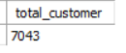
3. Churn Rate
Query : SELECT ROUND(SUM(CASE WHEN Customer_Status = 'Churned' THEN 1
ELSE 0 END)*100/COUNT(*),2) AS churn_rate_percentage
FROM telecom_customer_churn;
Result :
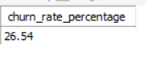
4. Average_Monthly_Charge_Of_Churners
Query : SELECT ROUND(AVG(Monthly_Charge),2) AS avg_monthly_charge
FROM telecom_customer_churn
WHERE Customer_Status = "Churned";
Result :
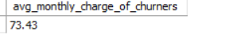
5. Avg_Tenure_in_Months_of_Churners
Query : SELECT ROUND(AVG(Tenure_in_Months),2) AS avg_lifespan_of_churners
FROM telecom_customer_churn
WHERE Customer_Status = 'Churned';
Result :
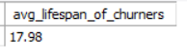
Charts
1. Churn by contract type
Query : SELECT Contract , COUNT(*) AS churn_count
FROM telecom_customer_churn
WHERE Customer_Status = 'Churned'
GROUP BY Contract;
Result :
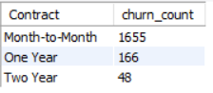
2. Top 5 Churn Reason
Query : SELECT Churn_Reason , COUNT(*) as Reason_Count
FROM telecom_customer_churn
WHERE Customer_Status = 'Churned'
GROUP BY Churn_Reason
ORDER BY reason_count DESC
lIMIT 5;
Result
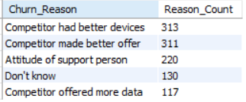

3. Internet Type Performance
Query:SELECT Internet_Type , ROUND(SUM(CASE WHEN Customer_Status =
'Churned' THEN 1 ELSE 0 END)*100/COUNT(*),2) AS
Churn_rate_by_internet_type
FROM telecom_customer_churn
GROUP BY Internet_Type;
Result :
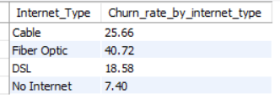

4. Count and rate by Churn Category
Query : SELECT Churn_Category , COUNT(*) AS category_count ,
ROUND(COUNT(*)/(SELECT COUNT(*) FROM telecom_customer_churn
WHERE Customer_Status = 'Churned'),2)*100 AS category_rate
FROM telecom_customer_churn
WHERE Customer_Status = 'Churned'
GROUP BY Churn_Category
ORDER BY category_count DESC;
Result :
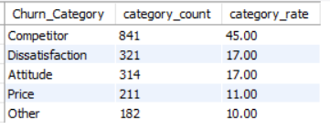

5. Payment Method Vs Churn
Query : SELECT Payment_Method, Customer_Status, COUNT(*) AS
num_of_customer
FROM telecom_customer_churn
GROUP BY Payment_Method, Customer_Status
ORDER BY Payment_Method, Customer_Status;
Result :
